**To Mayor of Gazoldo,**

Thank you for using our services and monitoring the situation of air pollution in the region. We at Wiseair have customers as our utmost priority.

With our analysis on the data provided by the sensors, your concern is right. We have observed that in winters, especially in November, the air pollution( particulate matter) is extremely high. It is evident from the figure below. The plot has Air quality in Y axis and time in X axis. The temperature spikes in November is the reason sensors observed high Air quality.

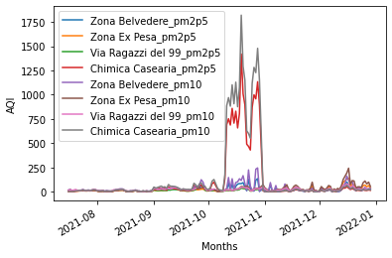

Moreover, we analyzed the data in a shorter time frame of 15 minutes and we observed a correlation of air temperature with PM10 and we found a negative correlation, especially for Zona Ex Pesa and Via ragazzi, reported in the table below.

A negative correlation meaning an inverse relation of the two parameters. The higher the magnitude of the correlation factor, the higher is the impact.

| Zone/Sensor location | Correlation with Air temperature |
| --- | --- |
| Zona Belvedere | -0.2241 |
| Zona Ex Pesa | -0.5212 |
| Via Ragazzi del 99 | -0.45 |
| Chimica Caseria | -0.09 |